**MMP 350 CSS Week 3 Class 1**

**Table of contents**

Goals for Week 3 Class 1 1

Where We’re Headed in Week 4 1

Wireframe tools 2

Exercise 1: Wirefy 2

Purpose 2

Background 2

Step 1 2

Step 2 2

Step 3 3

Exercise 2: Moqups 3

Step 1 3

Step 2: Sign up for Free Account 3

Step 3 3

Step 4: Edit the header 4

Step 5: Add an icon to the header 5

Step 6: Insert image 5

Step 7: Add a link 6

Step 8: Preview the Result 6

Step 9: Create a login page 7

Step 10: Modify the Login Link on your home page to launch the login page. 8

Step 11: Add an Interaction to the Submit button 9

Step 12: Save your Project 9

Step 13 9

Responsive / Adaptive Design 9

Class Exercise: Analysis of an Adaptive Webpage 9

Readings 10

Homework 11

## Goals for Week 3 Class 1

1. Schedule Website Critiques
2. Review of homework
3. Review wireframing
4. Moqups exercise
5. Discussion about responsive and adaptive design

## Where We’re Headed in Week 4

Today’s class is intended to provide students with a foundation for their mid-term assignment, as well as to prepare them for the next two weeks where we will be implementing prototypes, first using the bootstrap framework and then with SASS.

## Wireframe tools

What is wireframing?

A wireframe is a schematic diagram or blueprint for a website.

Wireframes are used by designers to visualize, and thereby understand, the relationship between screen elements.

## Exercise 1: Wirefy

### Purpose

To use the wirefy tool to examine the structure of webpages.

### Background

Wirefy is a bookmarklet. A bookmarklet is a bookmark stored in a web browser that contains JavaScript commands that add new features to the browser.

Wirefy lets you turn any webpage into a wireframe.

### Step 1

Go to wirefy.com:

<https://www.wirify.com/about/wirify-overview-and-why/>

### Step 2

Make your bookmarks toolbar active:

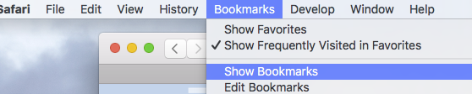

Figure 1: Activating the bookmarks toolbar in Safari.

Drag the Wirefy link (Wirify by Vokside) to your bookmarks toolbar (figure 2)

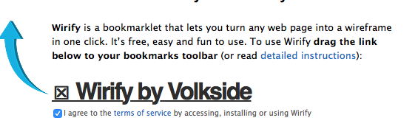

Figure 2

### Step 3

Go to a favorite website and click on the Wirify by Volkside link on your bookmarks toolbar (figure 3).

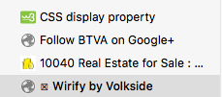

Figure 3

## Exercise 2: Moqups

#### Purpose

To explore common features of the most common collaborative wireframing tools, moqups.com

### Step 1

Go to moqups.com

<https://app.moqups.com/edit/page/ad64222d5>

### Step 2: Sign up for Free Account

To activate your free account, click on the Free Plan link at the bottom of the moqups.com homepage (figure 4).

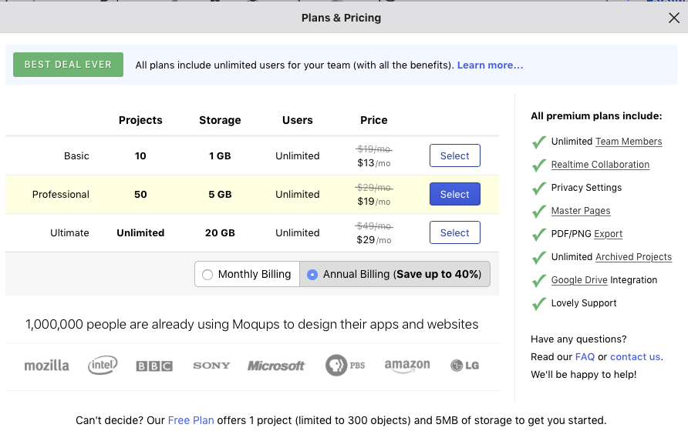

Figure 4: The moqups.com homepage

### Step 3

Once you have created a project, review the instructions on the main page and then delete them.

### Step 4: Edit the header

Edit the main heading to say [Your Name] Portfolio (figure 5)

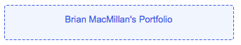

Figure 5: Adding a header to a moqups.com page

Double click on the text to change its formatting (figure 6)

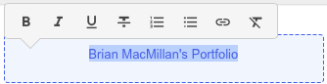

Figure 6: Applying basic text formatting

Macintosh HD:Users:newuser:Desktop:Screen Shot 2017-02-15 at 9.30.00 AM.png

Figure 7: Changing to Format mode

Change the color and font size of your heading text. The settings in figure z result in the output in figure 8.

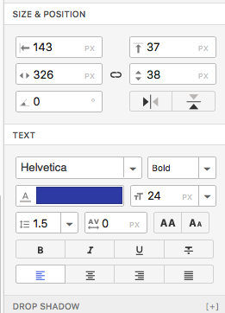

Figure 8: The text format in moqups.

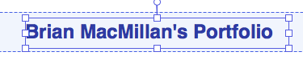

Figure 9: The results of the text formatting decisions illustrated in figure 8.

### Step 5: Add an icon to the header

Click on the Icons icon on the left hand panel (figure 10).

Macintosh HD:Users:newuser:Desktop:Screen Shot 2017-02-15 at 9.39.23 AM.png

Figure 10: The Icons menu item

Select an icon from the fly-out panel that appears, for example the Android icon (figure 11).

Macintosh HD:Users:newuser:Desktop:Screen Shot 2017-02-15 at 9.40.39 AM.png

Figure 11: The Android icon from the moqups icon fly-out panel.

Drag the icon to your header and format the results. They should look something like figure 12.



Figure 12: header with icon

### Step 6: Insert image

Click on the Images menu item on the left hand menu and then Upload images link to add an image to your project (figure 13).

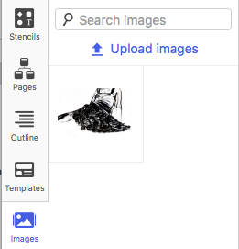

Figure 13: Once you have uploaded an image it will appear in the images palette Only jpgs, png and gif formats are supported.

### Step 7: Add a link

Click on the Stencils icon to get access to basic HTML elements (figure 14)

Macintosh HD:Users:newuser:Desktop:Screen Shot 2017-02-15 at 10.03.41 AM.png

Figure 14: the Stencils menu item.

Click on the Link menu item and drag a link to your page (figure 15).

Macintosh HD:Users:newuser:Desktop:Screen Shot 2017-02-15 at 10.08.43 AM.png

Figure 15: The Link menu item

Double click on the link and change its text to read Login.

### Step 8: Preview the Result

Click on the Preview button in the upper right hand corner of your screen to preview your work as if it were a functioning webpage.

Macintosh HD:Users:newuser:Desktop:Screen Shot 2017-02-15 at 10.45.02 AM.png

Figure 16

Click on the Edit Project button to exit from preview mode.

Macintosh HD:Users:newuser:Desktop:Screen Shot 2017-02-15 at 10.45.38 AM.png

Figure 17

Your page should now look something like what is illustrated in figure 18.

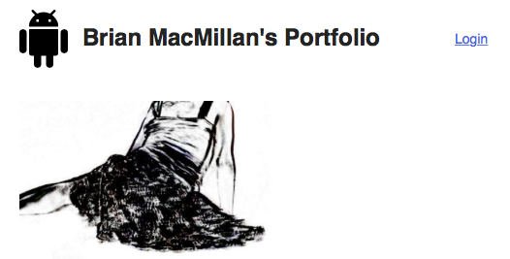

Figure 18: Moqup page with icon, header, image and link.

### Step 9: Create a login page

Click on the Pages icon and then on the New page option (figure 19). Name the page Login. While you’re at it, rename your first page to Home Page.

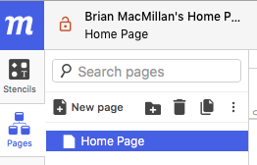

Figure 19: The pages icon.

Now edit the login page so that it looks like figure 20. This page will use Heading, Label, Text Input, Text Area, Checkbox and Button elements.

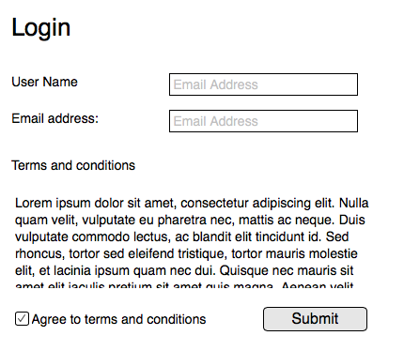

Figure 20

### Step 10: Modify the Login Link on your home page to launch the login page.

Navigate to your home page, select the Login link and then click on the Interactions button on the upper right hand corner of the screen. It has a lightening bolt icon (figure 21).

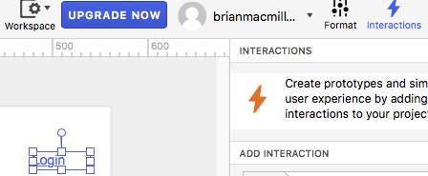

Figure 21

To add an interaction you need to select an event (Click), and action (Go to Specific Page) and a target page (Login) (see figure 22)

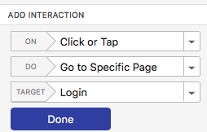

Figure 22

### Step 11: Add an Interaction to the Submit button

Add an interaction to the Submit button that returns the user to the Homepage.

### Step 12: Save your Project

To save your project clock on the main menu, which is activated by clicking on the mockups logo on the upper left hand corner of the page (figure x) and selecting Save. Note that unless you pay, you can only save one project and you cannot export your work.

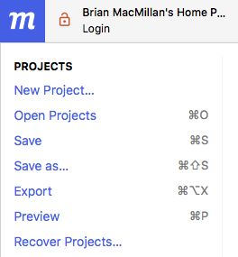

Figure 23: the Mockups Main menu.

### Step 13

If you finish this exercise before the rest of the class, either read the articles linked to at the bottom of this document, or begin your homework assignment.

## Responsive / Adaptive Design

**Responsive design** is the practice of designing websites that change style and layout to fit a variety of devices with different dimensions, screen densities and functionalities to create an optimal viewing experience based on a single template. In responsive design, the rules will move fluidly between sizes, applying new dimensions to every dimension.

Like responsive design, **adaptive design** changes based on screen size and density, but adaptive design generally pinpoints specific breaking points or thresholds and creates designs for those points.

Both concepts are rooted in the idea of **progressive enhancement**, the idea that websites should be designed to provide the basic content to any device, while progressively introducing enhanced design possibilities for modern devices.

### Class Exercise: Analysis of an Adaptive Webpage

Go to <http://www.houstonchronicle.com>

Change the size of the screen. What happens?

Activate the Inspect Element tool (figure 24)

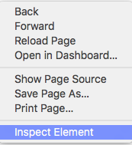

Figure 24: Right click to inspect elements of a web page.

If you are using Firefox change the location of the Inspect Element frame clicking on the left hand button, illustrated in figure 25, below. What happens?

Macintosh HD:Users:newuser:Desktop:Screen Shot 2017-02-15 at 1.51.52 PM.png

Figure 25. In Firefox you use the icon on the left to move the position of your inspection frame.

Answer: The width of the content adjusts dynamically.

Question: What is the width of the header element?

Answer: 100%

Question: Why a percentage and not an absolute number?

Question: What is the width of the body element?

Question: How does the width of the content element vary as screen width changes?? What is the maximum size of #content? What is the minimum size?

Question: The site uses a very common framework. Which one?

## Readings

1. [Responsive design](http://alistapart.com/article/responsive-web-design)
2. [Fixed, fluid and elastic layouts](https://www.smashingmagazine.com/2009/06/fixed-vs-fluid-vs-elastic-layout-whats-the-right-one-for-you/)
3. [Adaptive vs. Responsive](https://css-tricks.com/the-difference-between-responsive-and-adaptive-design/)
4. [Progressive enhancement](http://alistapart.com/article/understandingprogressiveenhancement)

## Homework

1. Mockup your Midterm Project.
2. Read the articles in the readings section